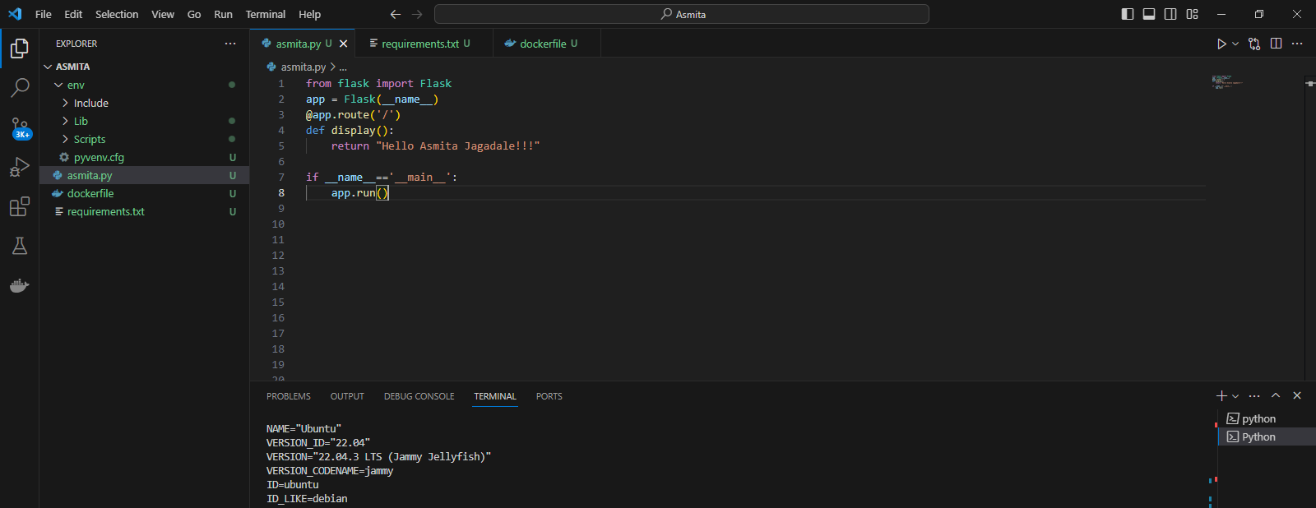

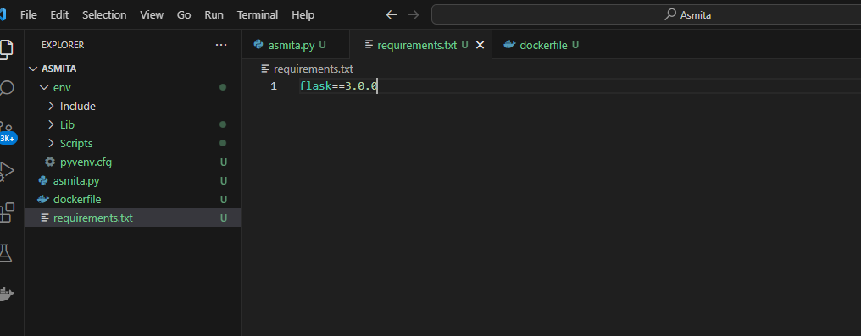

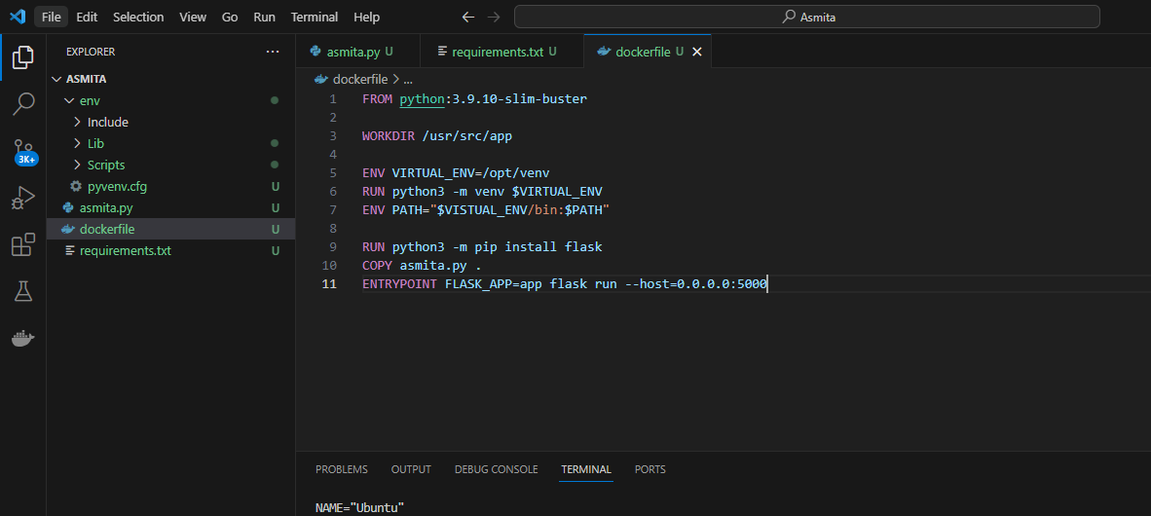

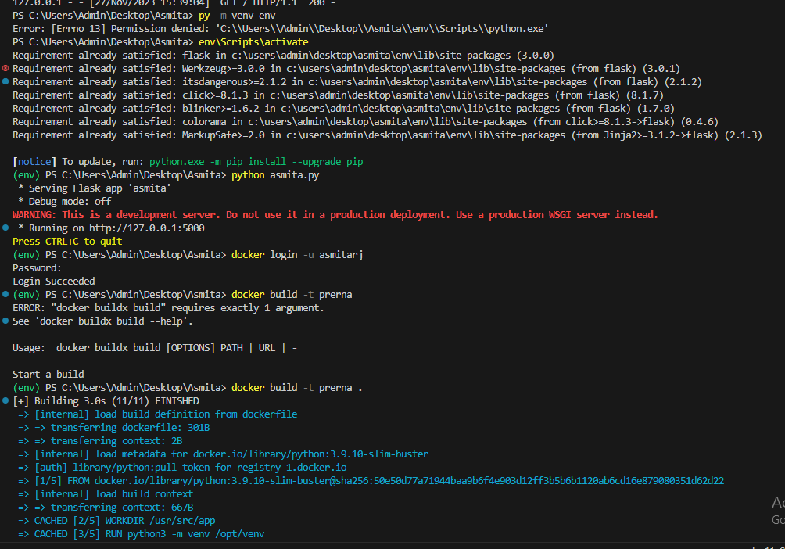

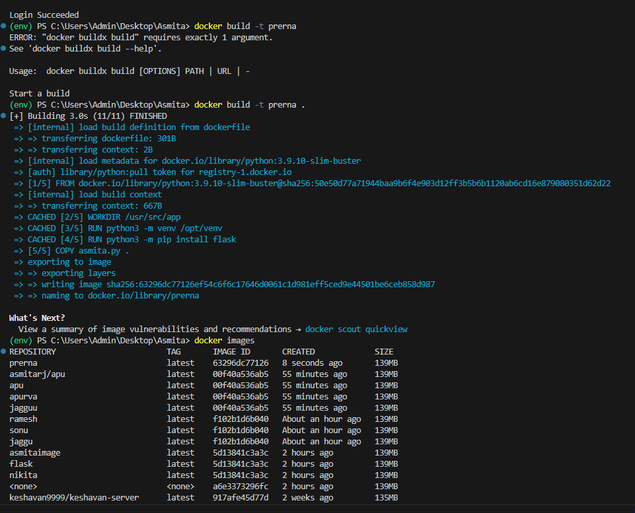

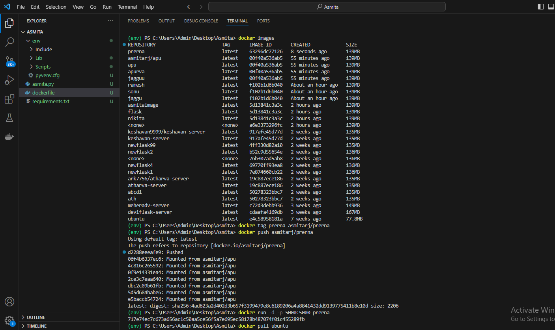

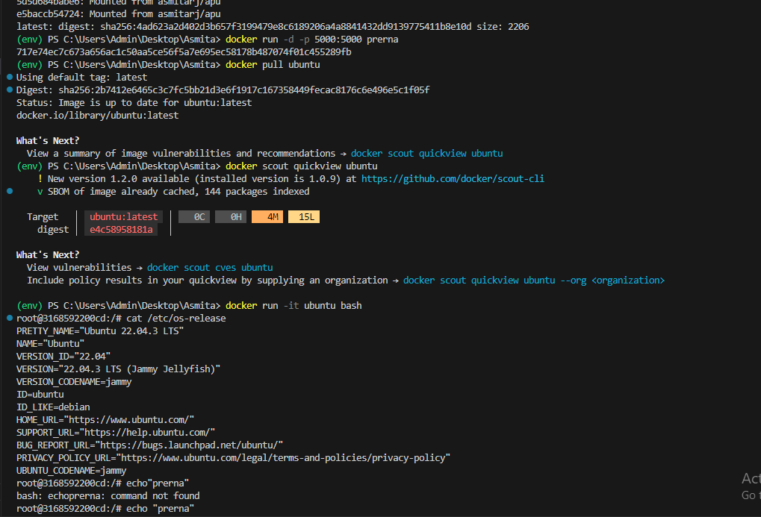

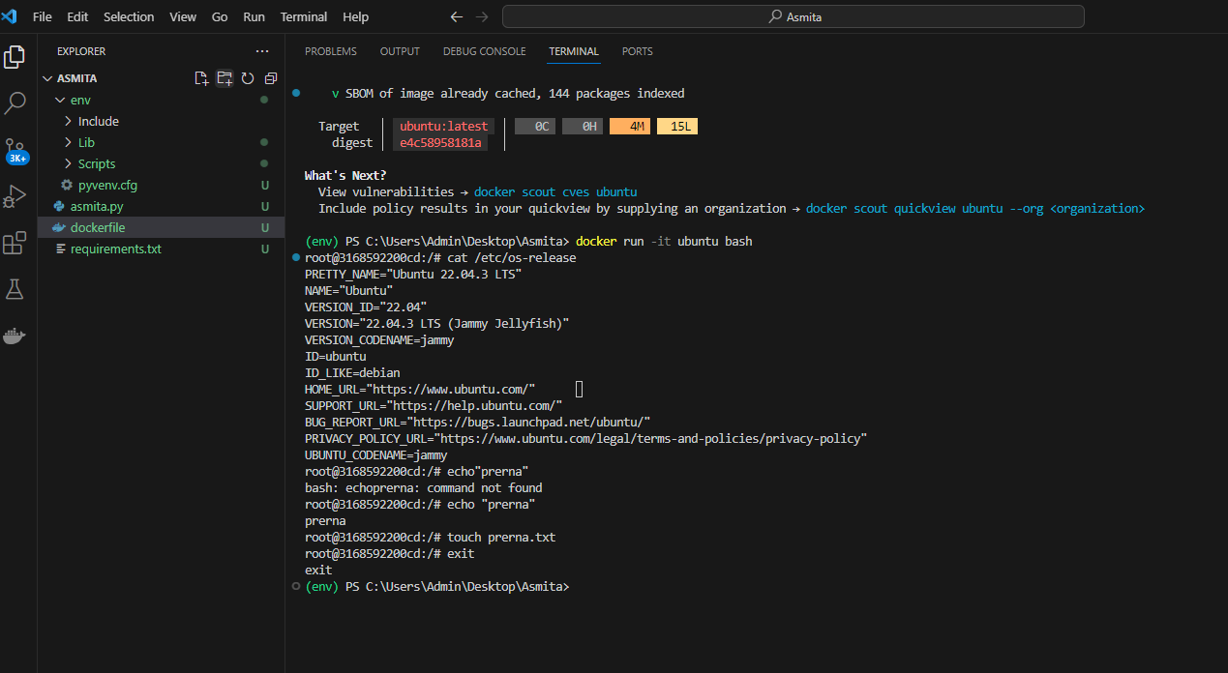

Requirements:

flask==3.0.0

Asmita.py:

from flask import Flask

app = Flask(__name__)

@app.route('/')

def display():

    return "Hello Asmita Jagadale!!!"

if __name__=='__main__':

    app.run()

Dockerfile:

FROM python:3.9.10-slim-buster

WORKDIR /usr/src/app

ENV VIRTUAL_ENV=/opt/venv

RUN python3 -m venv $VIRTUAL_ENV

ENV PATH="$VISTUAL_ENV/bin:$PATH"

RUN python3 -m pip install flask

COPY asmita.py .

ENTRYPOINT FLASK_APP=app flask run --host=0.0.0.0:5000

